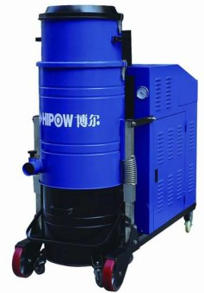

兮HIP® W博
博尔PV- FC脉冲反吹型 重型工业吸尘器
HIPOW PV-FC pulse back blowing heavy-duty industrial vacuum cleaner
博尔PV- FC脉冲反吹型重型工业吸尘器简介：
lntroducUon to HIPOW PV-FC Pulse Blowback Heavy lndus1r;a1 Vacuum Cleaner
博尔P V - FC系列脉冲反吹型重型 工业吸尘 器采用涡 轮高压风 机为动力琼 ，设备采用聚酷纤维过滤筒过滤 ， 过滤精度为0 . 3微米— 1 0微米供选择 ， 采用脉 冲反吹方式自动清理过滤筒，设备可以选配空压机提供气泪，电控系统采用名牌电气元件， 带有脉冲控制仪，适用千电子、制药、化工＼机榄等行业。
The HIPOW PV-FC series pulse back blowing heavy-duty industrial vacuum cleaner uses a turbine high-pressure fan as the power source, and the equipment uses polyester fiber filter cartridges for filtration, with a filtration accuracy of 0.3 microns to 10 microns for selection. The filter cartridges are automatically cleaned using pulse back blowing method, and the equipment can be equipped with an air compressor to provide air source. The electrical control system uses branded electrical components with pulse controllers, suitable for industries such as electronics, pharmaceuticals, chemicals, and machinery
特Fea点ture：s

、 机身带有脚轮， 适合工厂各种工作环境使用 ；
- 、 可以连续24小时工作， 适合生产线上连续使用 ；
3、聚酣纤维过滤筒过滤， 过滤效果好；
4 、 脉冲反吹清理过滤滤筒， 自动化程度高， 清理效果好；
- The body is equipped with casters, suitable for various working environments in factories;
- Can work continuously for 24 hours, suitable for continuous use on production lines;
- Polyester fiber filter cartridge filtration, good filtration effect;
- Pulse back blowing cleaning of filter cartridges,
with high degree of automation and good cleaning effect;

工作原理：
Working principle

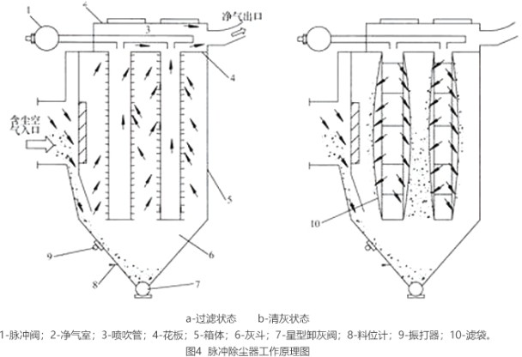
博尔PV-FC系列工业吸尘器， 在真空泵提供的负压下， 含尘气体进入吸尘器后，由千气流断面突然扩大及旋风分离的作用， 气流中—部分粗大颗粒在动和惯性力作用下沉降在集尘桶中；粒度细＼密度小的尘粒进入过滤筒后，由千过滤及筛选等组合效 应，使粉尘沉积在滤筒表面上，净化后的气体排气管经风机排 出，滤筒阻力随滤筒表茵粉尘层厚度的虐加而增大。阻力达到某
—规定悄时进行清灰（也可以定时处理）。此时PLC程序控制电磁脉冲阀的启闭，首先—分室提升阀关闭，将过滤气流载断，然后电磁脉冲阀开启，压缩空气以及短的时间在上稻体内迅速膨胀，润入滤筒，使滤筒膨胀变形产生振动，并在茫向气流冲刷的作用下，附着在滤袋外表面上的粉尘被剥离落入集尘筒中。清灰完毕后，电磁脉冲阀关闭，提升阀打开，该室又恢复过滤状态。清灰各室依次进行，从第－室清灰开始至下—灰涓灰开始为—个清灰周期。脱落的粉尘掉入集尘桶中。
HIPOW PV-FC series industrial vacuum cleaners, under the negative pressure provided by the vacuum pump, contain dust gas that enters the vacuum cleaner. Due to the sudden expansion of the airflow cross-section and the effect of cyclone separation, some coarse particles in the airflow settle in the dust collection bucket under the action of dynamic and inertial forces; After fine particle size and low density dust particles enter the filter cartridge, due to the combined effects of filtration and screening, the dust deposits on the surface of the filter cartridge. The purified gas exhaust pipe is discharged by a fan, and the resistance of the filter cartridge increases with the increase of the thickness of the dust layer on the surface of the filter cartridge. When the resistance reaches a certain specified value, ash cleaning can be carried out (or timed processing can be perfonned). At this point, the PLC program controls the opening and closing of the electromagnetic pulse valve. Firstly, the lift valve of the first chamber is closed, cutting off the filtered airflow. Then, the electromagnetic pulse valve is opened, and compressed air and a short period of time rapidly expand in the upper chamber, flowing into the filter cylinder, causing the filter cylinder to expand and deform, causing vibration. Under the action of reverse airflow erosion, the dust attached to the outer surface of the filter bag is peeled off and falls into the dust collection cylinder. After the ash cleaning is completed, the electromagnetic pulse valve is closed, the lifting valve is opened, and the chamber returns to filtering state. The cleaning process is carried out sequentially in each room, starting from the first room to the next cleaning cycle. The detached dust falls into the dust collection bucket.

兮HIP® W博
博尔PV- FC脉冲反吹型 重型工业吸尘器
HIPOW PV-FC pulse back blowing heavy-duty industrial vacuum cleaner

技术参数：
Techn;cal parameters

尘桶容量Volume(L) | 55 | 55 | 125 | 125 | 125 | 125 | 125
电压 Voltage(V) | 380 | 380 | 380 | 380 | 380 | 380 | 380
吸力Max.Vacuum(kpa) | 26 | 27 | 30 | 31 | 33 | 33 | 36
噪音 Noise level(db)A | 75 | 75 | 75 | 75 | 80 | 80 | 80
风量Airflow(m3/h) | 316 | 316 | 536 | 536 | 1260 | 1260 | 1260
重呈Weight(kg) | 196 | 196 | 280 | 280 | 360 | 360 | 360
吸尘口径Suction Caliber(mm) | 50 | 50 | 76 | 76 | 100 | 100 | 100
尺寸Dimension s L*W*H(mm) 1400*650*1500 1600*700*1800

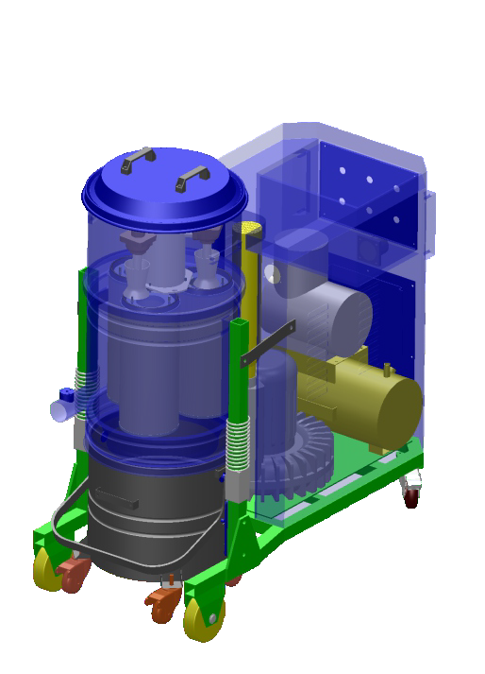
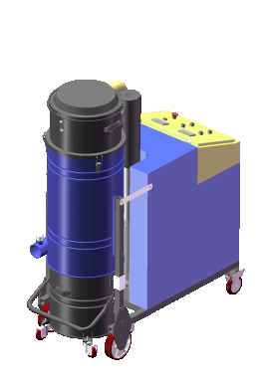
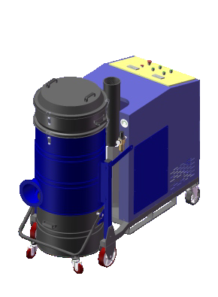
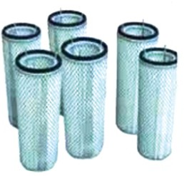
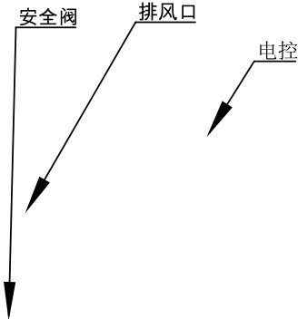
Filtering system
过滤系统：

PV -FC系列聚酷纤维滤筒过滤， 保证设备的过滤效果， 过滤精度为0 . 3 - 10微米。
The PV-FC series polyester fiber filter cartridge ensures the filtration effect of the equip ment, with a filtration accuracy of 0.3-10 microns.
HP-LT-D-178500-3
2 3

HP-LT-D-178400-3
HP-LT-D-178680-3

Equipment component diagram

气包 ＿＿＿＿ ＿
皿
设备部件图：
竺
嘘
归
二

? ---荨
J

.. 风 机
2 3 4 5 6 7

St 『 uctu,al d;mens;on d;ag,am
结构尺寸图：

尘桶 吸尘口滤筒 反吹管电磁阀气包 安全阀

排风口
- 电控
- 空压机
- 万向刹车轮
- 风机
- 固定轮

勹
1
ooocI
008
oos

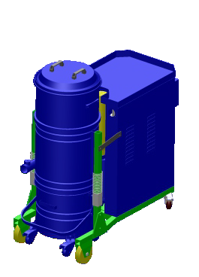
100
a
戎
'y
I!I
只

.!\.

\<l
L
三\,
＼｀｀｀

PV30FC/PV40FC PV55FC/PV75FC PV90FC/PV130FC/PV200FC

